Architecture Design Assignment

Name: Woo Wei Lin

Matric number: 206067

1. You are working in company XYZ required you to develop a design package for library, and develop the following diagram:
2. Class Diagram

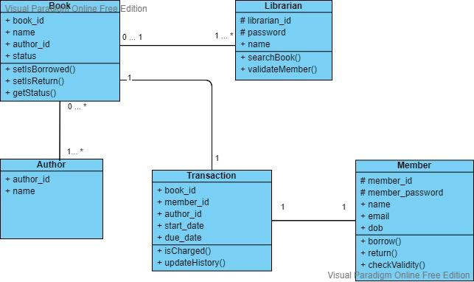

1. Sequence Diagram for borrow a book from library

